TEROS12 Arduino Uno Testbench Setup
The software setup is intended for Windows. If you are on a Mac please let me know so I can fix the guide
Software Downloads:
Arduino IDE: https://www.arduino.cc/en/software/
- Select your operating system and launch the executable file downloaded
- Good news! The testbench is now 10x more simple now that we’re using an Arduino Uno – this is all that is needed!!
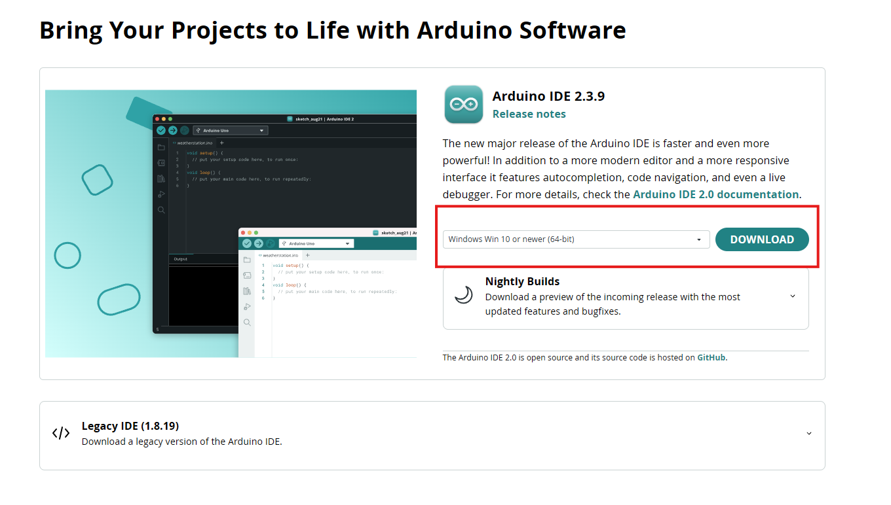

TEROS12 Configuration and Setup
Below is a rough diagram of the TEROS testbench. We’ve already attached wires to different parts of the Arduino – however, please validate that they are in the correct place. To connect the TEROS, plug the wires from the TEROS12 into the wires plugged into the following ports on the Arduino. The top of the Arduino has all port labels accordingly
Teros Wire | Arduino Uno Port | Notes
Brown | 5V | Connect to the opposite end of the limit switch
Grey | GND | Any GND port will work – use the one that a wire is already plugged into
Orange | 10

Diagram of the setup (I’ve tried my best to map the wire colours, however they may vary)
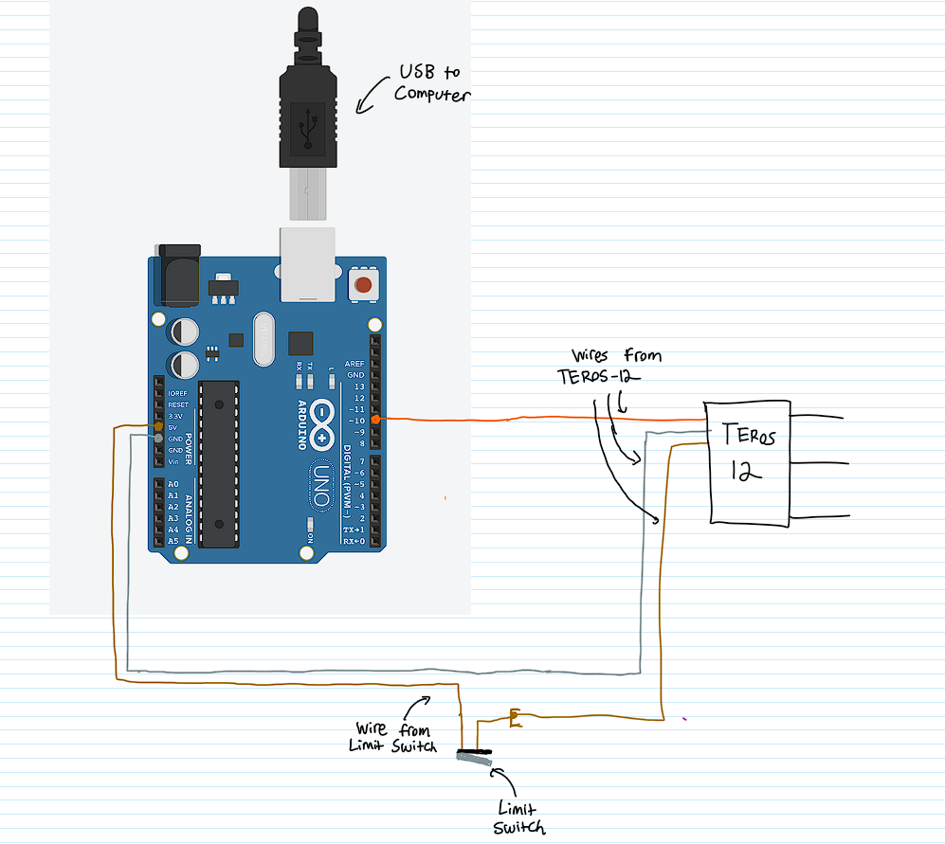
Note: The brown wire from the Arduino will likely be spliced with another wire so we can connect it. The brown wire leaves the limit switch.
Arduino Configuration
- Open Arduino IDE
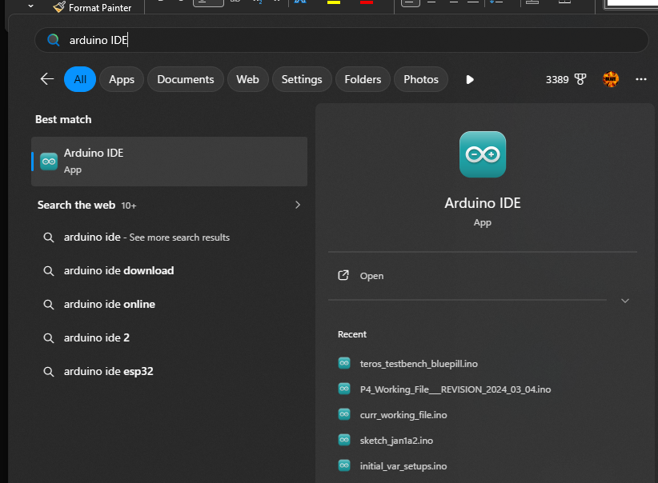
- Once opened, a blank file will open. Click on File > Open and navigate to the directory where you downloaded the TEROS12 code. Select teros_testbench_uno.ino and click open
- The file should then open, and look something like this
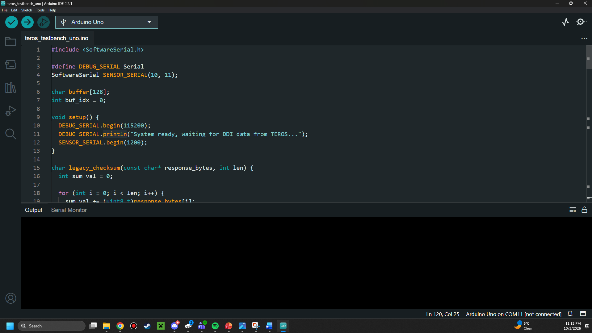
- Plug the Arduino into your computer
- From the dropdown menu, select “Arduino Uno”
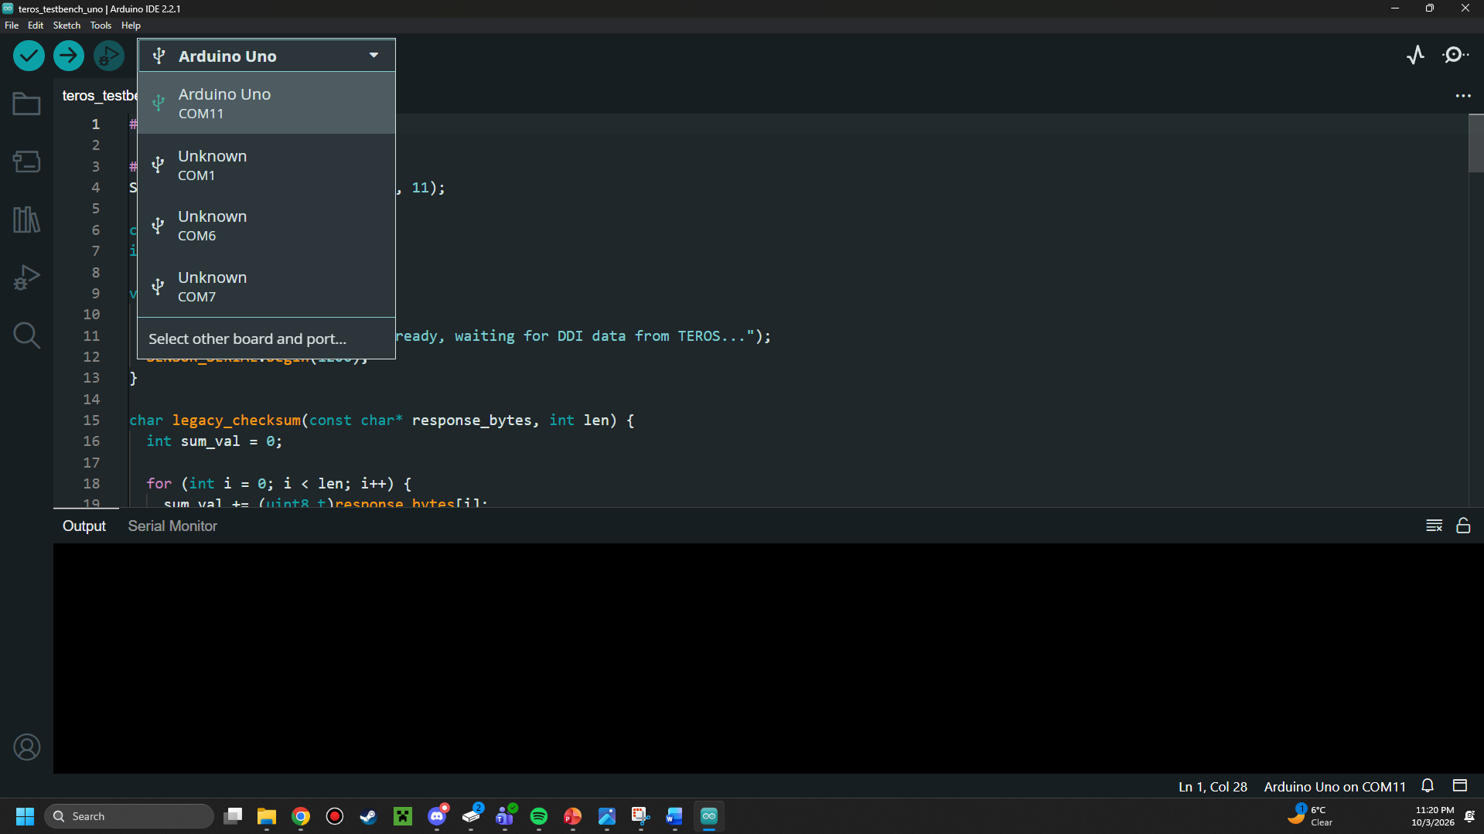
- To build the code, you can use the checkmark on the top left screen. Ensure that there are no errors when building the code before you proceed.
- When you see “Done Compiling” and no red errors, this is a strong indicator that the build has worked properly.
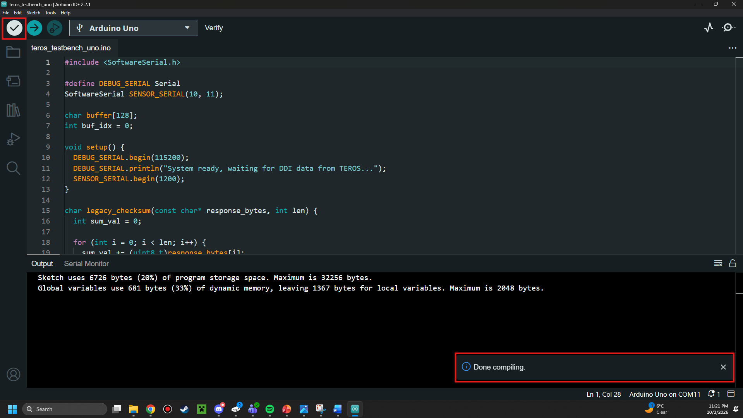
- Click on the arrow to flash the code to the Arduino
- A done uploading message will appear once the flash is completed.
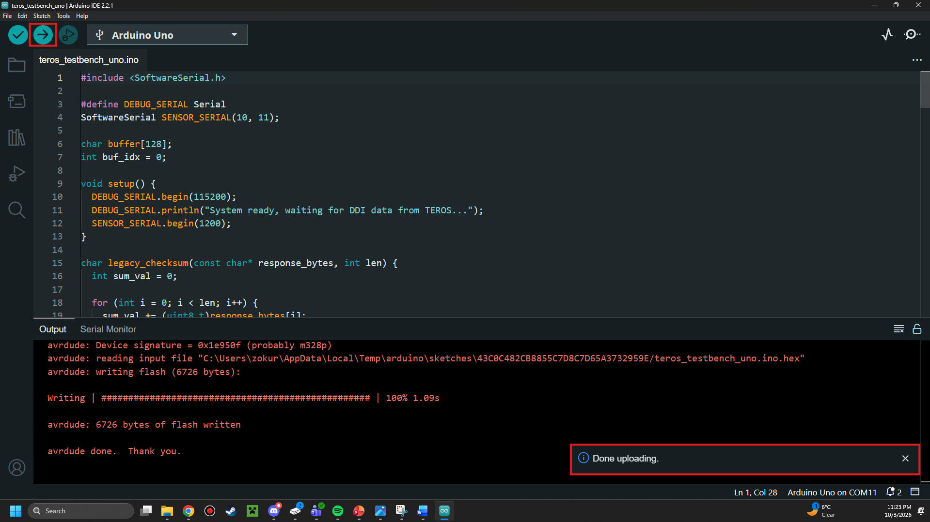

Viewing Data Output from the TEROS12
- Plug the Blue Pill into your computer via the attached USB cable (not using the STLink v2)
- In Arduino IDE, navigate to Tools > Serial Monitor
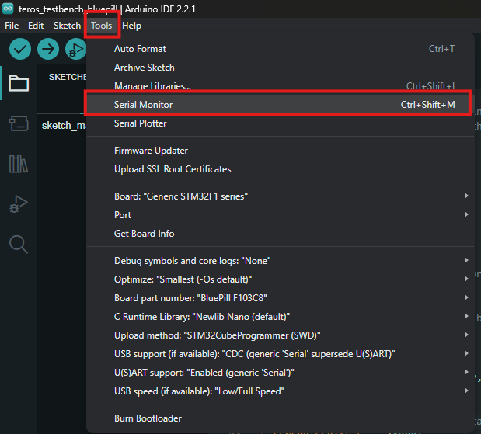

- The serial monitor will open at the bottom of the interface.
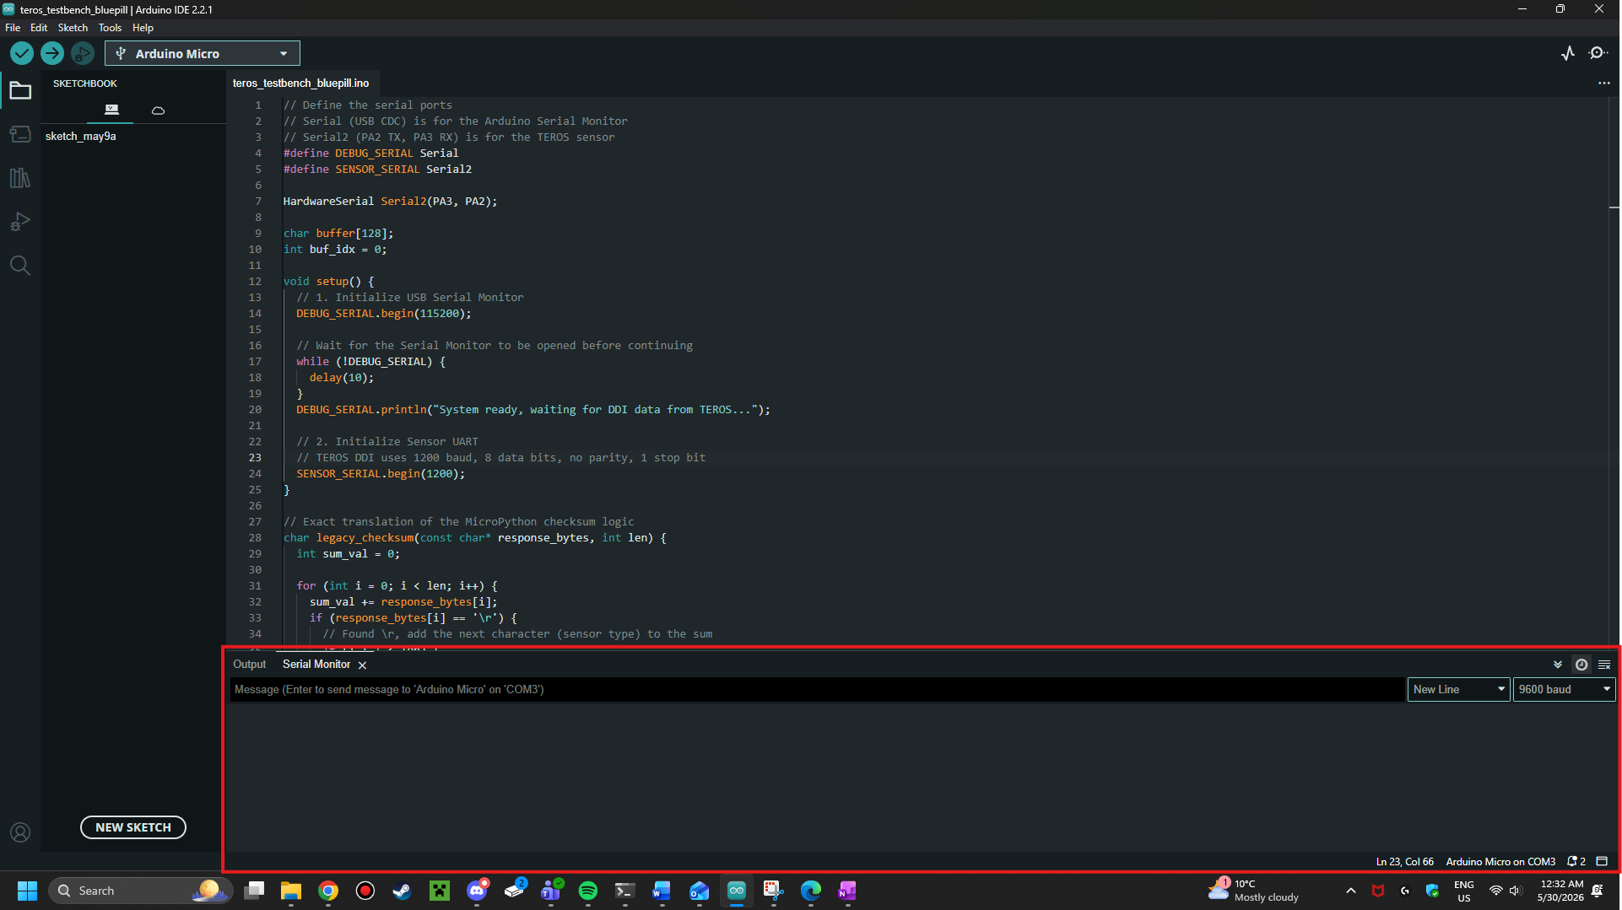
- In the top right corner of the Serial Montior, you will see something that says “9600 baud”. Open this and change the baud rate to 115200.
  - You may have to scroll to find the correct baud rate.
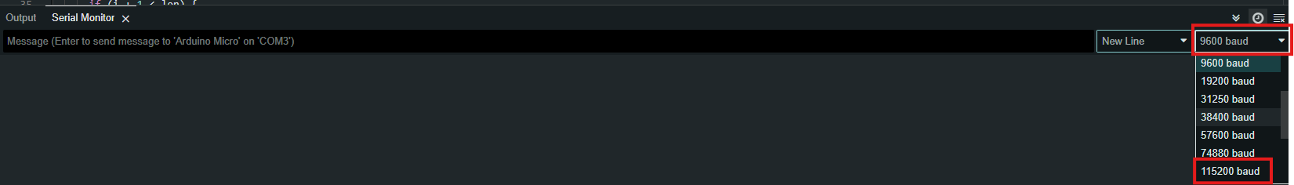

IMPORTANT: OBTAINING DATA FROM THE TEROS12
The TEROS12 does not send data automatically, and will only send data when power is cycled. We are emulating this through the limit switch, which essentially gives the TEROS12 power each time it is pressed!
To view information from the TEROS12, follow these steps:
- Ensure the Arduino Uno is connected to the computer over USB
- Press and hold the limit switch until a new line shows in the Serial Monitor
- Release the limit switch.
- Repeat steps 2-3 for subsequent data values.

To disable the system, simply unplug the USB cable from your computer!

If you have any questions, do not hesitate to reach out to me on Teams either directly or via the sensors group chat!

